
Cloudli Connect Training
Create a New Grouped Extension (Ring Group)
Lynn Daviault | 11/5/25 | Cloudli Connect Training

How to Create a New Grouped Extension (Ring Group)
This guide provides a straightforward process for creating a new grouped extension (aka Ring Group). By following these steps, users can easily configure a Grouped Call Extension that connects multiple extensions simultaneously, ensuring that calls are answered promptly.

- Click “Telephony”
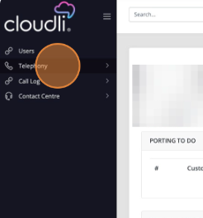

- Click “Extensions”
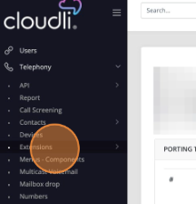

- Click “Grouped Extensions”
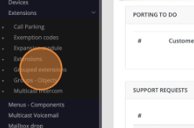

- Click “NEW”
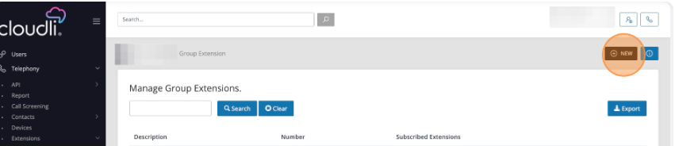

- Create the Name of the Grouped Extension i.e., Ring All
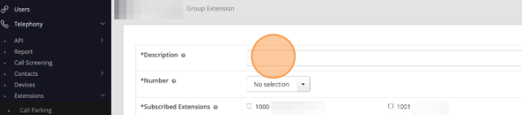

- Type Ring All
- Select the desired number from the list of available extension numbers
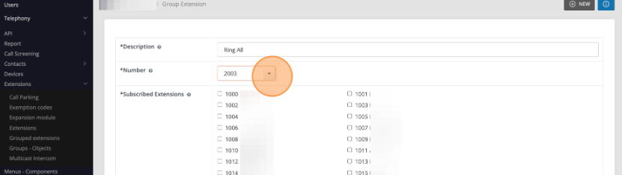

- Click the box to check off who you like to have in the Grouped Extension
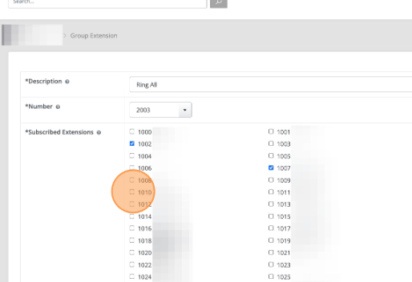
- Optional: Choose a Voice mailbox for the Group Extension
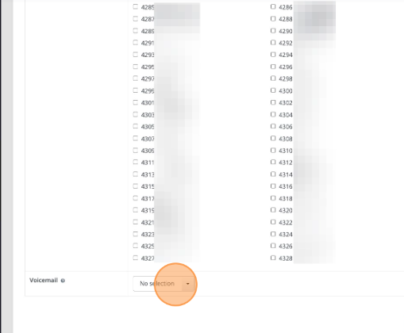

- Click “Save” to finish
